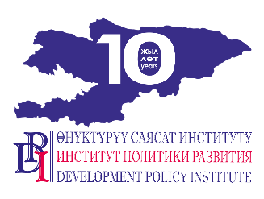
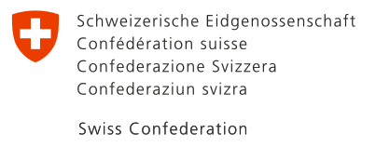

PRESS RELEASE

July 14, 2020
Bishkek, Kyrgyzstan

Switzerland provided humanitarian aid to vulnerable people of Naryn, Chui and Osh oblasts through municipalities

Due to the COVID-19 pandemic in Kyrgyzstan, the Swiss project “Strengthening Voice and Accountability” has allocated more than 6 million soms to 30 local self-governments of Naryn, Chui and Osh oblasts to help around 5000 families in need.

This project is funded by the Government of Switzerland through the Swiss Agency for Development and Cooperation (SDC) and implemented by Development Policy Institute.

The humanitarian aid has been provided in the form of food packages: flour, pasta, granulated sugar, buckwheat, condensed milk, tea, vegetable oil. Each family in need has received this food package worth about 1,200 soms. The list of vulnerable people mainly included low-income families with children with disabilities.

All products have been locally purchased through an open competition. To ensure transparency and accountability local commissions were created, which included representatives of aiyl okmotu and mayor offices, deputies of aiyl kenesh, members of joint monitoring and evaluation groups and active representatives of local communities.

The commissions have participated in receipt and distribution of assistance to persons in need of humanitarian aid according to the list taking into account previously received assistance from other sources.

In addition, the Swiss project has provided antiseptics for visitors and staff of aiyl okmotu and mayor offices.

For more details please contact: Nurgul Dzhamankulova, project PR specialist: 0555 / 0500 313-385, 0770 771-711, njamankulova@dpi.kg

For more details about Swiss Development Cooperation in Kyrgyzstan, please contact: Tursunai Chodurova, tel.: (0770) 710054, email: tursunai.chodurova@eda.admin.ch

***

The Government of Switzerland provides assistance for the development of the Kyrgyz Republic to improve the well-being of the population. Over the last 25 years Switzerland has granted more than CHF 430 million to Kyrgyzstan in the form of technical, financial and humanitarian support. For more information, please visit https://www.eda.admin.ch/bishkek.

